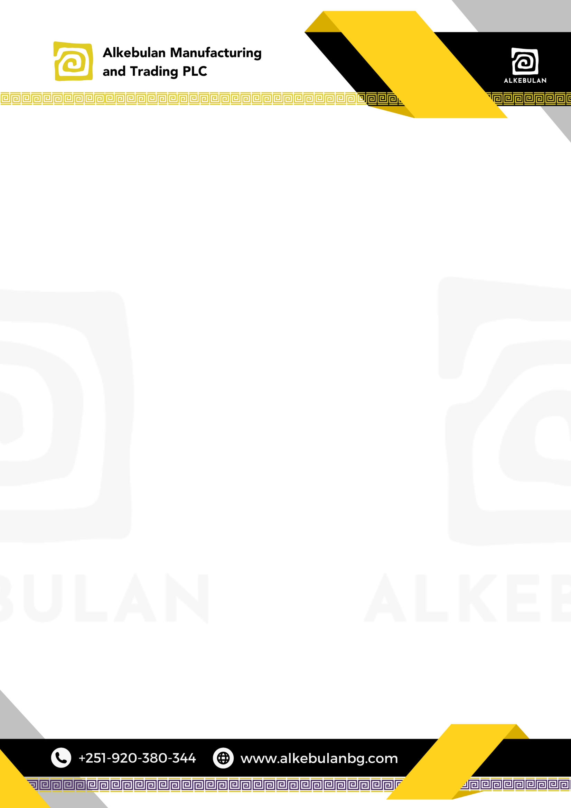

# DISTRIBUTION AGREEMENT ALKEBULAN MANUFACTURING & TRADING PLC

**AND**

**ZEKARYA MUSETEFA ERGENO**

**Date:** July 17, 2025

**Alkebulan Manufacturing & Trading PLC** (hereinafter referred to as “Alkebulan”), a company registered and existing under the laws of Ethiopia, with its principal office located at Addis Ababa.

# AND

**Zekarya Musetefa Ergeno** (hereinafter referred to as "Distributor"), a Purchasing and Distributing Party residing in Ethiopia.

This Distribution Agreement (the "Agreement") is made and entered into on **July 17, 2025**, by and between Alkebulan and **Zekarya Musetefa Ergeno**.

**WHEREAS**, Alkebulan has obtained the rights to be the official distributor of Dangote Cement.

**WHEREAS**, Alkebulan desires to appoint Distributor as its distributor to handle all distribution-related activities on behalf of Alkebulan.

**WHEREAS**, Distributor agrees to act as a distributor and perform the necessary distribution- related activities on behalf of Alkebulan.

**WHEREAS**, this agreement is for the distribution of Dangote Cement.

**NOW, THEREFORE**, in consideration of the mutual covenants and promises contained herein, the parties hereto agree as follows:

# Appointment of Distributor

* 1. Alkebulan hereby appoints Distributor as its distributor for Dangote Cement.
  2. Distributor accepts the appointment and agrees to act as the distributor of the Products.

# Duties and Responsibilities of Distributor

* 1. Distributor shall use its best efforts to promote, market, and distribute the Products within the territory.



* 1. Distributor shall handle all distribution-related activities, including but not limited to sales, marketing, logistics, and customer service.
  2. Distributor shall comply with all applicable laws and regulations in the performance of its duties under this Agreement.
  3. Distributor agrees to purchase a **minimum of 50,000 quintals of Dangote Cement from Alkebulan on a monthly basis**. This quantity shall be supplied every calendar month,

starting from the effective date of this agreement.

* 1. The current price per bag of Dangote Cement is 1045 Birr, but this price is subject to change based on market fluctuations.
  2. Payment for each purchase shall be made in advance into Dangote Cement PLC's account using Alkebulan Manufacturing and Trading PLC's Code.

# Term and Termination

* 1. This Agreement shall commence on the date first written above and shall continue in effect for a period of **twelve months**, unless terminated earlier in accordance with the provisions of this Agreement.
  2. Either party may terminate this Agreement by providing fifteen days' written notice to the other party.
  3. Upon termination of this Agreement, Distributor shall cease all distribution activities and settle any outstanding balance to Alkebulan.

# Confidentiality

* 1. Both parties agree to maintain the confidentiality of all proprietary information disclosed during the term of this Agreement.
  2. The confidentiality obligations shall survive the termination of this Agreement.

# Governing Law and Dispute Resolution

* 1. This Agreement shall be governed by and construed in accordance with the laws of the Federal Democratic Republic of Ethiopia.
  2. Any disputes arising out of or in connection with this Agreement shall be resolved

through good-faith negotiation. If unresolved, the matter shall be referred to arbitration in accordance with Ethiopian law in Addis Ababa, Ethiopia.



**IN WITNESS WHEREOF**, the parties hereto have executed this Agreement as of the day and year first above written.

# Distributor:

# Alkebulan Manufacturing & Trading PLC:

**Selamawit Zemene**

**Founder and CEO of Alkebulan Manufacturing & Trading PLC**

Signature: Date:

**Buyer:**

**Zekarya Musetefa Ergeno**

Signature: Date: